# MTH 441 Lab Assignment 2

### Viral Chitlangia

## P1

data.File1 <- read.csv("rocket_propellant.csv")  
model1 <- lm(Shear.Strength..psi. ~ Age.of.Propellant..weeks., data = data.File1)  
model1$coefficients

## (Intercept) Age.of.Propellant..weeks.   
## 2627.82236 -37.15359

## P2

data.File2 <- read.csv("delivery_times.csv")  
model2 <- lm(Delivery_Time ~ Number_of_Cases_x1 + Distance_x2, data = data.File2)  
model2$coefficients

## (Intercept) Number_of_Cases_x1 Distance_x2   
## 2.76356503 1.11355896 0.02421374

X <- cbind(numeric(length(data.File1$Observation)) + 1, data.File1)  
colnames(X)[1] <- "One"  
X <- X[, c(1, 4)]  
X <- as.matrix(X, nrow = length(X$'One'), ncol = 2)

## P3

# 1  
variance <- sum(model1$residuals^2)/(length(data.File1[,2]) - 2)  
variance

## [1] 9236.381

# 2  
varVec <- variance * solve(t(X) %*% X)  
Var <- diag(varVec)  
t <- model1$coefficients/Var  
t

## (Intercept) Age.of.Propellant..weeks.   
## 1.346070 -4.451165

## P4

# 1  
W <- vector()  
for (i in 1:5000) {  
 W <- append(W, rnorm(1)^2 + rnorm(1)^2 + rnorm(1)^2)  
}  
  
  
# 2  
hist(W)

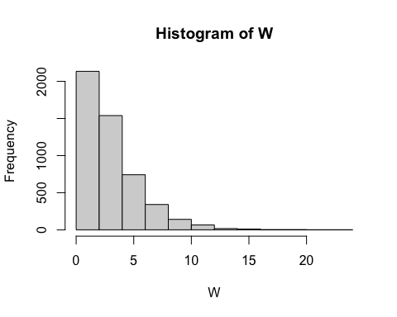

m <- mean(W)  
v <- var(W)  
  
# 3  
theoretical.mean <- 3  
theoretical.variance <- 6  
  
# 4  
m - theoretical.mean

## [1] 0.03344048

v - theoretical.variance

## [1] 0.2183001

## P5

# 1  
X <- matrix(rnorm(40, 5, 3), nrow = 8, ncol = 5)  
Px <- X %*% solve(t(X) %*% X) %*% t(X)  
if (norm(Px - Px%*%Px, type = "2") < 1e-6) {  
 print("Px is Idempotent")  
}

## [1] "Px is Idempotent"

# 2  
S <- NULL  
for (i in 1:5000) {  
 Y <- NULL  
 for (j in 1:8) {  
 Y <- c(Y, rnorm(1))  
 }  
 Y <- as.matrix(Y, 1, 8)  
 S <- c(S, t(Y) %*% Px %*% Y)  
}  
  
  
# 3  
hist(S)

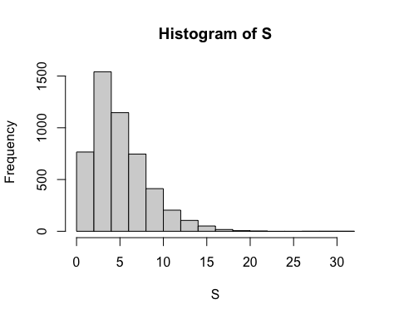

m <- mean(S)  
v <- var(S)  
m

## [1] 4.997226

v

## [1] 10.27151

# 4  
theoretical.mean <- 5  
theoretical.variance <- 10  
  
# 5  
m - theoretical.mean

## [1] -0.002774452

v - theoretical.variance

## [1] 0.2715088

## P6

# 2  
P.X.1 = Px  
P.X.2 = diag(1, 8, 8) - P.X.1  
df1 <- qr(P.X.2)$rank  
df2 <- qr(P.X.1)$rank  
S <- NULL  
for (i in 1:5000) {  
 Y <- NULL  
 for (j in 1:8) {  
 Y <- c(Y, rnorm(1))  
 }  
 Y <- as.matrix(Y, 1, 8)  
 S <- c(S, as.vector(t(Y) %*% P.X.2 %*% Y / df1)/(t(Y) %*% P.X.1 %*% Y / df2))  
}  
  
  
# 3  
hist(S)

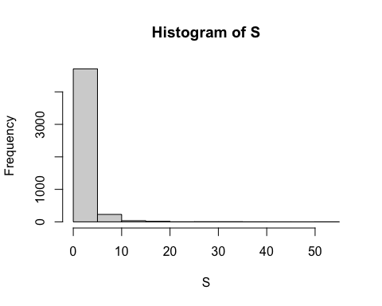

m <- mean(S)  
v <- var(S)  
m

## [1] 1.626773

v

## [1] 6.170386

# 4  
theoretical.mean <- 5/3  
theoretical.variance <- (2 * (5^2) * (3 + 5 - 2)) / (3 * (5 - 2)^2 * (5 - 4))  
theoretical.mean

## [1] 1.666667

theoretical.variance

## [1] 11.11111

# 5  
m - theoretical.mean

## [1] -0.03989382

v - theoretical.variance

## [1] -4.940726